Blood Pressure (Spline Interpolation)

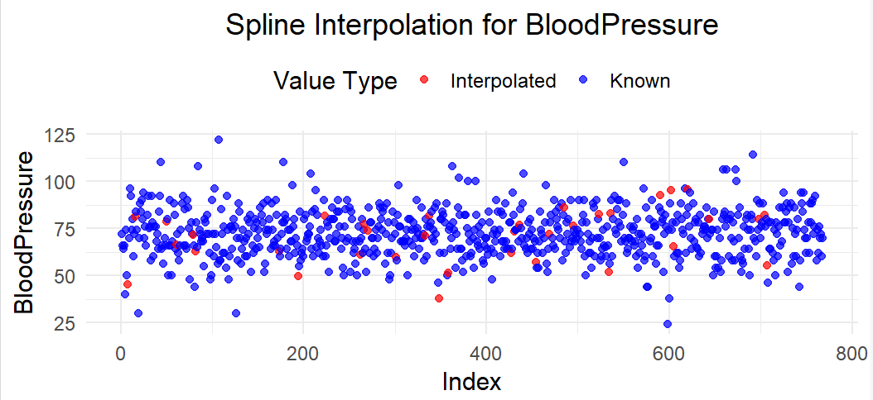
For the BloodPressure variable, we addressed the missing values using spline interpolation.

What the Plot Shows:
- Blue Points:
  - These are the actual BloodPressure values that were recorded in the dataset.
  - They show the natural trend of the data, spread consistently across the dataset.
- Red Points:
  - These are the values we estimated using spline interpolation.
  - They were calculated to fill the missing gaps and align with the overall trend of the data.

Why Use Spline Interpolation?
Spline interpolation works by fitting smooth curves between data points. It’s perfect for situations like this because:
- It creates smooth transitions without introducing abrupt changes.
- It captures trends in the data while maintaining a natural flow.

Key Takeaways:
The interpolated values (red points) blended perfectly with the known values (blue points). This ensures the dataset is complete and ready for further analysis without any major disruptions to the trend.

BMI (Before and After Interpolation)

Before Interpolation:

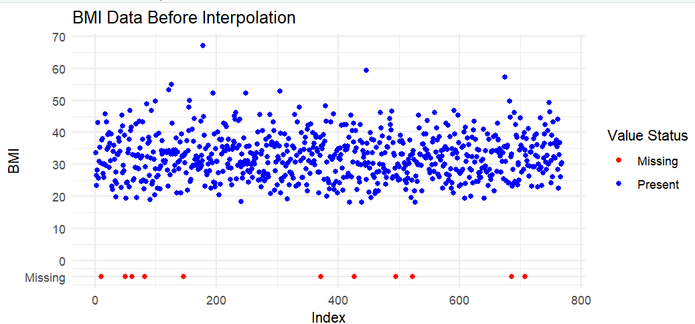
The first scatterplot highlights the missing BMI values in red and the recorded ones in blue. To make the missing data visible, we temporarily set those values to -5.
What This Shows:
- The missing BMI values are scattered throughout the dataset.
- There isn’t any noticeable pattern, but the missing values stand out clearly, which is helpful for identifying gaps.

After Interpolation:

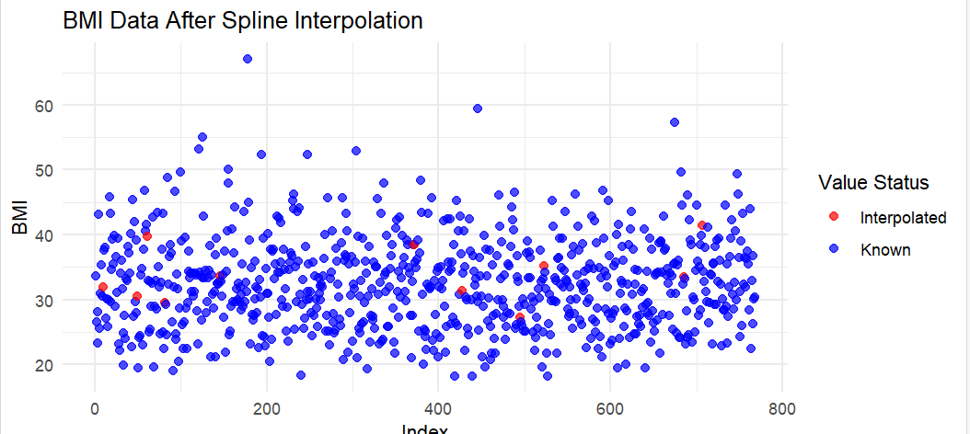
After applying spline interpolation, the second plot shows the missing values filled in:
- Red Points: Represent the interpolated BMI values.
- Blue Points: The original recorded values.

What We Learned:
- The red points fit smoothly with the existing trend of blue points.
- The interpolation didn’t create any weird spikes or unnatural values, which means it worked as intended.

Takeaway:
This process gave us a complete BMI dataset that maintains the overall pattern, making it ready for any further analysis.

Glucose (Before and After Interpolation)

Before Interpolation:

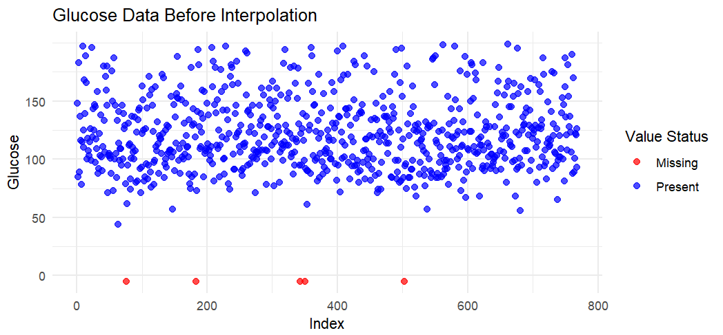
This plot shows the Glucose variable with missing values marked in red. As before, we placed these missing values at a placeholder level (-5) so we could see where they were in the dataset.

What We Observed:
- Most of the Glucose data is present (blue points), but a few scattered red points show where data is missing.

After Interpolation:

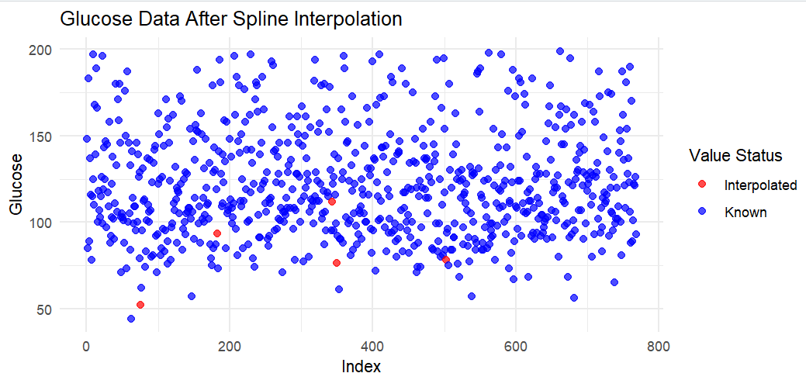
Using spline interpolation, we filled in the missing Glucose values. The updated plot now includes:
- Blue Points: Original data values.
- Red Points: Interpolated values filling in the gaps.

Why This Matters:
The interpolated values align seamlessly with the known data, preserving the natural trend of the Glucose variable. This ensures a smooth and complete dataset for further analysis.

Skin Thickness (Before and After Interpolation)

Before Interpolation:

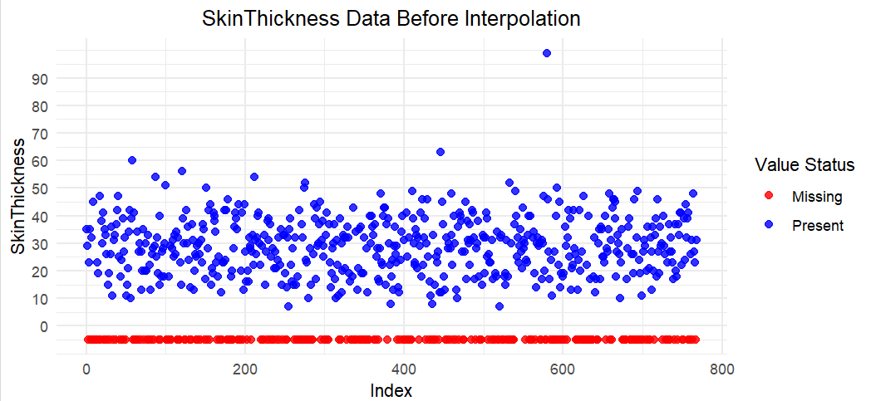
For the SkinThickness variable, the missing values (red points) were again plotted at a placeholder level (-5) to highlight their locations. The present values (blue points) give us an idea of the original distribution.

What We Learned:
- Missing values were scattered across the dataset.
- This visualization helped us see the extent of missing data and decide how to handle it.

After Interpolation:

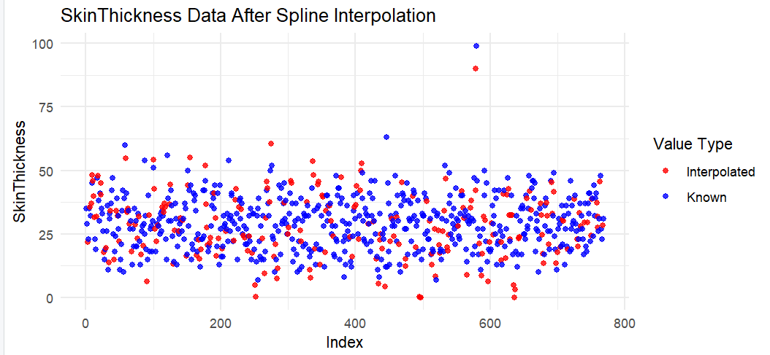
After using spline interpolation, we filled in the missing values:
- Red Points: Now represent the interpolated values for SkinThickness.
- Blue Points: Represent the original recorded values.

Insights:
The interpolated points fit right into the dataset’s trend, keeping the pattern smooth and logical.

Takeaway:
With the interpolation, SkinThickness is now complete and consistent, ready for further analysis or modeling.
Forget what ever down here is, Ignore Insuline

Insulin (Challenges and Observations)
Insulin was a tricky variable to deal with because:
- Nearly 50% of the data was missing (374 out of 768 rows).
- There were also extreme outliers, including biologically impossible negative values.
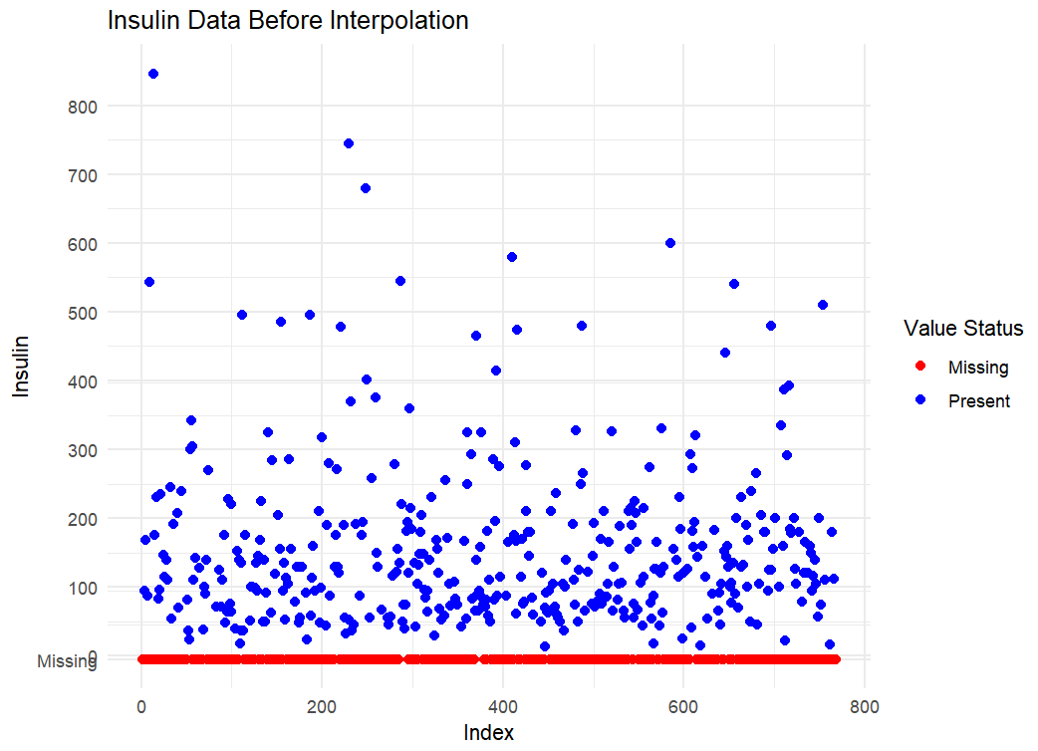

For the Insulin variable, I couldn’t perform accurate spline interpolation because almost half of the data was missing, and there were extreme outliers. Even after cleaning the data, it didn’t make sense to move forward since the results wouldn’t be reliable. Will try with python

